SYDNEY WESTERN CITY PLANNING PANEL

Panel No: | PPSSWC-3.
DA Number: | 2019/464/1.
Local Government Area: | Camden.
Development: | Camden Council works depot upgrade including demolition, earthworks, tree removal, revised vehicular entry, new and relocated administration buildings, new and relocated workshops, relocated washbay, new weighbridge, waste and recycling truck parking, expansion of staff parking, covered depot fleet parking, community recycling centre, building maintenance workshops, bulk material storage area, stormwater management and associated works.
Street Address(es): | 5 Millwood Avenue, Narellan.
Applicant / Owner: | Camden Council.
Date of DA Lodgement: | 13 June 2019.
Number of Submissions: | None.
Recommendation: | Approve with conditions.
Regional Development Criteria (Schedule 7 of State Environmental Planning Policy (State and Regional Development) 2011): | Council development with capital investment value >$5 million.
List of All Relevant s4.15(1)(a) Matters: | - State Environmental Planning Policy (State and Regional Development) 2011.  - State Environmental Planning Policy (Infrastructure) 2007.  - State Environmental Planning Policy No 33 - Hazardous and Offensive Development.  - State Environmental Planning Policy No 55 - Remediation of Land.  - Sydney Regional Environmental Plan No 20 - Hawkesbury-Nepean River.  - Camden Local Environmental Plan 2010.  - Camden Development Control Plan 2011.
List all Documents Submitted with this Report for the Panel’s Consideration: | - Assessment report.  - Camden Local Environmental Plan 2010 assessment table.  - Camden Development Control Plan 2011 assessment table.  - Recommended conditions.  - Proposed plans.
Report Prepared By: | Mathew Rawson, Team Leader DA Assessment – West.
Report Date: | February 2020.

Summary of Section 4.15 matters

Have all recommendations in relation to relevant s4.15 matters been summarised in the Executive Summary of the assessment report? | Yes.

Legislative Clauses Requiring Consent Authority Satisfaction

Have relevant clauses in all applicable environmental planning instruments where the consent authority must be satisfied about a particular matter been listed and relevant recommendations summarised in the Executive Summary of the assessment report? | Yes.

Clause 4.6 Contraventions to Development Standards

If a written request for a contravention to a development standard (Clause 4.6 of the LEP) has been received, has it been attached to the assessment report? | N/A.

Special Infrastructure Contributions

Does the DA require Special Infrastructure Contributions (s7.24)? | No.

Conditions

Have draft conditions been provided to the applicant for comment? | Yes.

PURPOSE OF REPORT

The purpose of this report is to seek the Sydney Western City Planning Panel’s (the Panel’s) determination of a development application (DA) for the Camden Council works depot upgrade at 5 Millwood Avenue, Narellan.

The Panel is the consent authority for this DA as the capital investment value (CIV) of the development is $6,835,080. This exceeds the CIV threshold of $5 million for Council related development as prescribed under Schedule 7 of State Environmental Planning Policy (State and Regional Development) 2011.

SUMMARY OF RECOMMENDATION

That the Panel determine DA/2019/464/1 for the Camden Council works depot upgrade pursuant to Section 4.16 of the Environmental Planning and Assessment Act 1979 by granting consent subject to the conditions attached to this report.

EXECUTIVE SUMMARY

Council is in receipt of a DA for the Camden Council works depot upgrade at 5 Millwood Avenue, Narellan.

The DA has been assessed against the Environmental Planning and Assessment Act 1979, the Environmental Planning and Assessment Regulation 2000, relevant environmental planning instruments, development control plans and policies.

A summary of the assessment of all relevant environmental planning instruments is provided below with a detailed assessment provided later in the report.

State Environmental Planning Policy (State and Regional Development) 2011. | The Panel is the consent authority for this DA as the development has a CIV of $6,835,080 which exceeds the CIV threshold of $5 million.
State Environmental Planning Policy (Infrastructure) 2007 (ISEPP). | The development is traffic generating development and referral to the Roads and Maritime Service (now known as Transport for NSW) was required. Comments received from RMS have been addressed in the assessment of the DA and appropriate conditions recommended.
State Environmental Planning Policy No 33 - Hazardous and Offensive Development (SEPP 33). | The development will not breach SEPP 33’s screening thresholds for the storage of dangerous goods on the site. A condition is recommended that requires the quantities of dangerous goods to be transported to and from the site to be kept below SEPP 33’s screening thresholds. The development is not potentially hazardous or potentially offensive development as defined by SEPP 33.
State Environmental Planning Policy No 55 - Remediation of Land. | A preliminary site investigation (phase 1) contamination assessment was submitted with the DA. The site is suitable for the development.
Sydney Regional Environmental Plan No 20 - Hawkesbury-Nepean River (SREP 20). | The development is consistent with the aim of SREP 20 (to protect the environment of the Hawkesbury-Nepean River system) and all of its planning controls.
Camden Local Environmental Plan 2010 (Camden LEP). | The development is permitted in the applicable IN1 zone by the Camden LEP. The development is consistent with the zones’ objectives and acceptable in terms of the Camden LEP’s other matters for consideration.

The DA was publicly exhibited for a period of 14 days in accordance with Camden Development Control Plan 2011. The exhibition period was from the 5th to the 18th of July 2019. No submissions were received.

Based on the assessment, it is recommended that the DA be approved subject to the conditions attached to this report.

AERIAL PHOTO

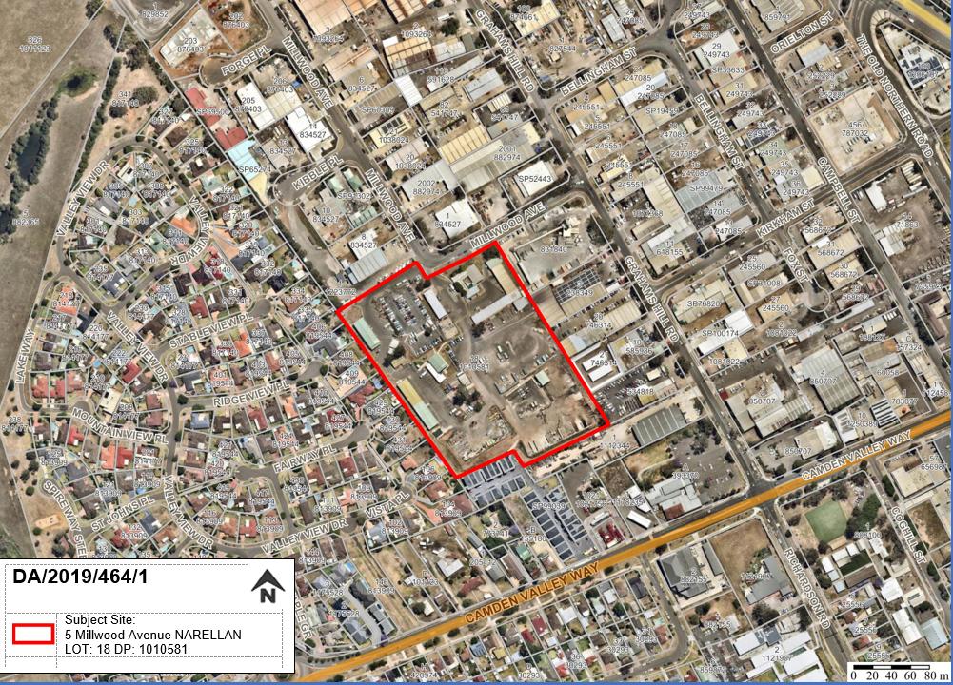
Figure 1: Aerial Photo

THE SITE

Camden Council Works Depot is located at No. 5 Millwood Avenue, Narellan. The site is a single allotment and the legal description of the site is Lot 18, DP 1010581. The site has an area of approximately 3.8 hectares and lies on the southern edge of an established light industrial area and at the interface with adjoining residential development to the south and west.

The site is currently occupied by several buildings, including offices, sheds and storage areas, uncovered storage areas, raw material storage bins and carparking areas. The Depot currently accommodates a number of Council’s services including parks and gardens, waste services, building services, as well as stores, mechanical workshops and abandoned vehicles.

The site surface is a combination of bitumen and concrete hardstand and gravel, with limited landscaped area.

The site is burdened by a 'restriction as to user' along the western boundary which requires the retention of the westernmost boundary fencing for acoustic attenuation. The proposed works do not impact on this boundary fence.

The surrounding area is characterized by low density residential development to the west and light industrial uses to the north and east. The southern interface consists of a mix of industrial land uses and a more recently completed medium density townhouse development on an ‘L’ shaped lot with access from Camden Valley Way. It is noted that the Depot is benefitted by a right of carriageway which allows access over the driveway for this adjoining townhouse development. The applicant has clarified that the use of this right of carriageway is for emergency exit only. A condition of consent is recommended to be imposed.

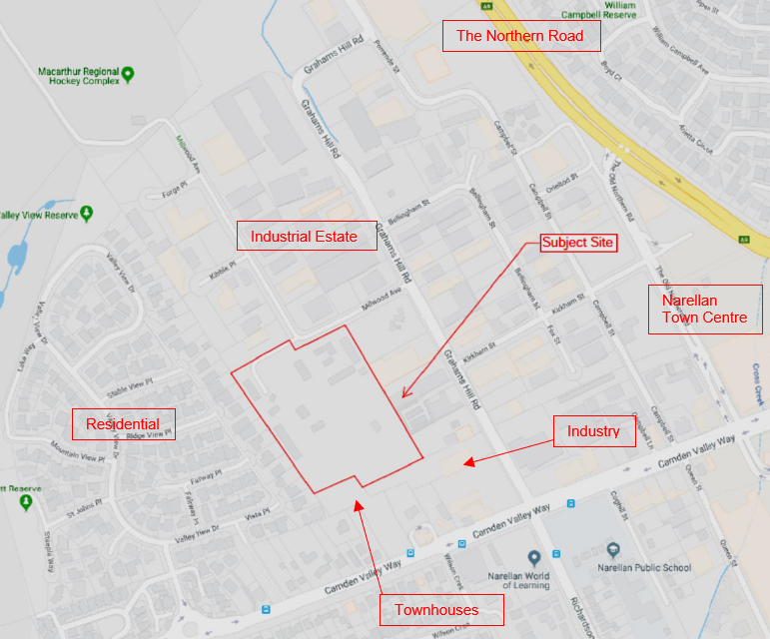
Figure 2: Site Context Plan

ZONING PLAN

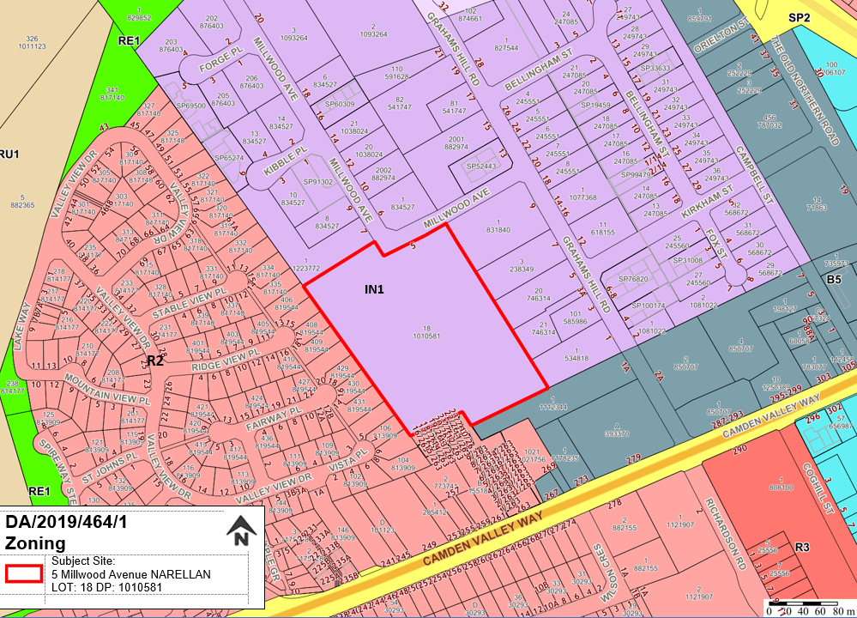

THE PROPOSAL

DA/2019/464/1 seeks approval for the Camden Council works depot upgrade.

Specifically, the development involves:

- Demolition - It is proposed to demolish a number of existing buildings and structures on the site as illustrated on the Demolition Plans that accompany the application.

- Earthworks - As part of the preparatory works, some cut and fill is proposed. Approximately 2,381m³ of cut and 300m³ of fill is to be undertaken across the site. The required fill will be taken from the cut material. However, there will be a balance of 2,081m³ of material. Rather than off-site disposal of this excess material, it is proposed that it be stored on the site and utilised to create additional soil depth for planting along the site perimeters. Any additional soil is proposed to be stored in the bulk material storage area, to be used as required at other sites throughout the LGA.

- Tree Removal and Replacement Planting / Landscaping - It is proposed to remove a total of 26 trees from the site in order to facilitate the proposed upgrade works. The trees to be removed comprise various species, with varying degrees of age, health and vigour. Of the 26 trees proposed to be removed, three have been identified by an Arborist as being in poor condition. The remaining 23 are considered by the Arborist to be in fair condition. The development also involves replacement planting with a total of 63 trees to be replanted in and around the Depot in addition to shrubs, hedges, grasses and groundcover.

- Revised Vehicular Entries - There are currently two vehicular entry points to the site located adjacent to each other and at the bend in Millwood Avenue. It is proposed to relocate the north-eastern entry to provide a new vehicular entrance at the north-eastern corner of the site that will service the waste and recycling truck parking; fleet and plant parking; and the bulk material storage area and weighbridge. The other existing vehicular entry from Millwood Avenue will be retained and will serve the staff and visitor parking areas and the mechanical workshops.

- Administration Building: Building 3 & Relocated Lunch/Meeting Room - A new single level Administration Building is proposed behind the staff parking area and adjacent to the existing staff lunchroom and amenities buildings. The building has a gross floor area of 644m² and will accommodate a reception area, amenities and locker room, meeting rooms, quiet rooms, offices and open plan workstations, as well as a kitchenette. At the southern end of the Administration Building, one of the existing metal buildings that comprise the current Administration Building is proposed to be relocated to provide an additional kitchen and lunchroom for staff use.

- Four Bay Mechanical Workshops: Building 10 - The current locations of the mechanical workshops and waste services are proposed to be swapped, with the mechanical workshops being relocated from the eastern to the western side of the site. The two existing workshop buildings currently occupied by waste services are to be retained and a new four bay double height mechanical workshop with a 59m² awning to cover an oil storage tank is proposed between the existing workshop buildings. The new workshop building is to be clad in metal sheeting (Colorbond Pale Eucalypt) to match the existing workshops and the new roller doors will match the existing (silver/grey).

- Relocation of Wash Bay - The existing wash bay is proposed to be relocated from the northern corner of the site to the western boundary, adjacent to the new four bay mechanical workshops.

- Weighbridge - A new weighbridge is proposed on the eastern side of the site, at the entry to the bulk material storage area. The weighbridge is being installed in order to accurately monitor / record the quantities of bulk materials being transported to and from the site.

- Waste and Recycling Truck Parking: Building 1 - The current waste and recycle vehicle fleet comprises 26 vehicles of differing descriptions, including single and dual control compactors, some with side arms, and rear loading garbage and recycling vehicles. Currently the fleet are stored on the southern side of the Depot, with some undercover in the workshops, but the majority are stored outside. It is proposed to relocate waste services to the north-eastern side of the site and provide covered parking for the fleet under cantilevered awnings supported on centrally located structural columns. Underneath, the bitumen surface is to be line marked to provide 26 truck parking bays. The awning will also cover the two existing fuel (diesel) bowsers and concrete apron which is to be retained on site. The bowsers are served by existing 38.4kL and 11.4kL underground storage tanks.

- Expansion of the Staff Parking Area - The existing staff parking area provides approximately 90 line marked parking spaces. It is proposed to provide an additional 45 staff and seven visitor parking spaces through an expansion on the north-eastern side of the existing staff parking area and replanning of the layout of the existing staff parking area. Three accessible parking spaces are to be provided.

- Proprietary Poly Tunnels (Container Dome Shelters): Buildings 19, 20, 21, 22, 23 & 24 and Plant Parking - In addition to the waste and recycling vehicles, the existing fleet housed at the Depot includes 20 light vehicles including a community bus and 19 utes; 33 trucks of various sizes and descriptions; 10 heavy plant including loaders, excavators, rollers and graders etc; and four tractors. These vehicles are currently parked across the site in an ad hoc manner. Therefore, in order to provide more orderly and formal parking for the fleet vehicles, it is proposed to provide a series of six proprietary poly tunnels that will provide shelter for the fleet vehicles. Each poly tunnel has a span of 21m and will be fixed to two shipping containers on either side. The apex of the domes is 5m above the height of the shipping containers (2.59m), with a total structure height of 7.59m. The shipping containers will be used for the storage of various items currently stored at the Depot. In addition to the covered parking for the larger plant, 24 parking spaces for fleet vehicles such as utilities is proposed to be constructed adjacent to the new Administration Building. This parking includes two (2) accessible spaces.

- Community Recycling Centre (CRC): Building 23 - With the aim of making it easier for households to recycle and remove problem waste from kerbside bin systems, the NSW Government is establishing a network of Community Recycling Centres across NSW, at which problem waste such as paints, batteries, smoke detectors, oils and fluorescent / compact fluorescent lights etc can be disposed of free of charge.

The CRC is proposed to be located in the south-western corner of the site, adjacent to the staff carpark and will allow residents to drive into a covered drop-off area and then leave again via the same site entry/exit driveway. The CRC will comprise a covered drive through structure that houses the various receptacles for different recyclable products. Members of the community will be able to attend the facility to recycle / dispose of unwanted or problem waste.

- Building Maintenance Workshops: Buildings 17 and 18 - Two (2) large sheds, with enclosed back and sides, roof cover and chainmesh fencing to the front are proposed in the southern corner of the site. These are to be used for storage of a variety of materials used for building maintenance and will each be divided into six internal bays separated by chainwire mesh walls that will be accessible to forklifts. Consistent with other buildings, these sheds will be clad in metal sheeting (Colorbond Pale Eucalypt).

- Bulk Material Storage Area - The existing bulk material storage area is to be retained. However, the concrete block storage bins are proposed to be slightly reconfigured in order to accommodate the new weighbridge and proposed new vehicular access/egress into the storage area. The concrete block walls in the north-eastern corner of the storage area are to be removed and relocated to create new bays and an enclosure to the western side of the storage area. Materials stored in the bulk material storage area include mulch, soils and organic softfall, concrete, road base/millings and other processed materials used by Council, as well as roadside/dumped waste collected by Council and held prior to disposal. The bulk materials storage area currently manages approximately 1,000 tonnes of material stored at any one time, with no more than a 6,000 tonne turnover per year. However, in order to cater for the increased demand due to population growth it is proposed that this be increased to between 12,000–15,000 tonnes per year. This will also provide additional capacity to store re-usable material, such as bark chips, VENM, recyclable road base and road millings and/or concrete etc.

- Stormwater Drainage - The existing stormwater drainage system at the Depot comprises a series of stormwater pipes and inlet pits / gully pits on the south-western side of the site that drain to two discharge points in Millwood Avenue. The proposed development involves the collection of stormwater from four sub-catchments in the site via a combination of grass swales, pipes, pits and v-drains which lead to one of three discharge points in Millwood Avenue after passing through either a bio-retention basin via a gross pollutant trap (GPT), a larger bio-retention basin or an online underground tank with water quality treatment cartridges.

- Staff Numbers - The Depot currently accommodates 34 indoor and 118 outdoor staff. However, in order to meet the growing needs of the community, it is likely that staff numbers will increase in the coming years. It is noted that the majority of outdoor staff work remotely through the local government area (LGA) and generally only attend the Depot at the start and end of their workday. As evidenced in the table below, the work hours of the various services are varied, such that staff attendance at the Depot is staggered throughout the day.

- Hours of Operation - Typically, the Depot services operate as outlined in the table below. However, due to the need to maintain emergency call out operations, the Depot requires 24-hour operation. No change to the current operating hours is proposed.

Service | Typical Start Time | Typical Finish Time
Waste Collection | 3:30am – 6.00am | 1.00am – 3.00pm
Parks and Gardens | 7.00am | 3.00am – 4.00pm
Office / Admin Staff | 8.00am | 4.00am – 6:30pm

- Staging – The proposed development is to be completed in 4 stages as indicated in the plans attached to this Report.

PANEL BRIEFING

Council staff briefed the Panel on the DA on 5 August 2019. The following discussion provides an assessment of how the issues raised by the Panel at the briefing have been addressed:

- “Traffic analysis addressing traffic impacts on local streets”

Traffic impacts are discussed in the likely impacts section of this report.

- “Adequacy of onsite staff and operational vehicles parking provision”

Parking impacts are discussed in the likely impacts section of this report.

- “Examination of onsite activities including:
  - Waste management and emissions;
  - Vehicle impact on streets;
  - Noise emissions including impact of 24 hour operations;
  - Impact of onsite vehicle movements.”

These impacts are discussed in the likely impacts section of this report.

- “Need for a specific site operations plan to regulate onsite activities.”

Adequate information has been provided in relation to the onsite activities in order to assess and determine that the development will not have any unacceptable impacts on the locality. An appropriate condition is recommended that requires this information be formalised into a Site Operations Plan which reflects the commitments made in relation to hours of operation, vehicular movements, noise, waste collection, etc.

ASSESSMENT

Environmental Planning and Assessment Act 1979 - Section 4.15(1)

In determining a DA, the consent authority is to take into consideration such of the following matters as are of relevance to the development the subject of the DA:

(a)(i) the provisions of any environmental planning instrument

The environmental planning instruments that apply to the development are:

- State Environmental Planning Policy (State and Regional Development) 2011.
- State Environmental Planning Policy (Infrastructure) 2007.
- State Environmental Planning Policy No 33 - Hazardous and Offensive Development.
- State Environmental Planning Policy No 55 - Remediation of Land.
- Sydney Regional Environmental Plan No 20 - Hawkesbury-Nepean River.
- Camden Local Environmental Plan 2010.

State Environmental Planning Policy (State and Regional Development) 2011 (SRD SEPP)

The SRD SEPP identifies development that is State significant or regionally significant development.

The Panel is the consent authority for this DA as the CIV of the development is $6,835,080. This exceeds the CIV threshold of $5 million for Council related development pursuant to Schedule 7 of the SRD SEPP.

State Environmental Planning Policy (Infrastructure) 2007 (ISEPP)

The ISEPP aims to facilitate the effective delivery of infrastructure across the State.

Roads and Maritime Services (RMS), now known as Transport for NSW

The DA was referred to RMS for comment pursuant to Clause 104 of the ISEPP as the development is classed as traffic generating development as it exceeds the size or capacity specified in Schedule 3 of the ISEPP.

RMS raised no objection to the development subject to comments regarding vehicular entrances and exits to the site. A condition requiring compliance with RMS’s comments is recommended.

State Environmental Planning Policy No 33 - Hazardous and Offensive Development (SEPP 33)

SEPP 33 regulates hazardous and offensive development and aims to ensure that the consent authority has sufficient information to assess whether or not development is hazardous or offensive.

SEPP 33 requires a consent authority to determine whether or not the development stores or requires the transport of dangerous goods above its screening thresholds. If any of SEPP 33’s thresholds are breached, a consent authority must then determine whether or not the development is hazardous or offensive by considering the measures proposed to reduce the impact of the dangerous goods.

The applicant has advised that although small quantities of chemicals / dangerous goods will be stored at the Depot, this will not constitute either a potentially hazardous industry, or a potentially offensive industry. The proposed development does not propose any additional storage of diesel fuels; nor any increase to the capacity of the existing re-fuelling points; nor any changes to filling and vent points; rather it only involves the covering of this fuelling area with a canopy. The Adblue storage tank is being relocated however this is not a potentially hazardous development.

Council staff have reviewed the development and are satisfied that the dangerous goods to be stored on the site will not breach SEPP 33’s screening thresholds.

A condition is recommended that requires the quantities of all dangerous goods to be transported to and from the site to be kept below SEPP 33’s screening thresholds. Should the dangerous goods quantities need to exceed SEPP 33’s screening thresholds in the future, a further application can be lodged to assess and address the exceedance.

Based on the above, the development is not considered to be hazardous or offensive development as defined by SEPP 33.

State Environmental Planning Policy No 55 - Remediation of Land (SEPP 55)

SEPP 55 provides a State-wide planning approach to the remediation of contaminated land.

Clause 7 of SEPP 55 requires the consent authority to consider if the site is contaminated. If the site is contaminated, the consent authority must be satisfied that it is suitable in its contaminated state for the development. If the site requires remediation, the consent authority must be satisfied that it will be remediated before the land is used for the development. Furthermore, the consent authority must consider a preliminary contamination investigation in certain circumstances.

The applicant has submitted a preliminary site investigation (phase 1) in support of the DA. This assessment found the site to be suitable for the development from a contamination perspective. Council staff have reviewed the assessment, agree with the findings and are satisfied that the site is suitable for the development.

A standard unexpected finds contingency condition is recommended that requires any contamination found during construction to be managed in accordance with Council's Management of Contaminated Lands policy.

Sydney Regional Environmental Plan No 20 - Hawkesbury-Nepean River (SREP 20)

SREP 20 aims to protect the environment of the Hawkesbury-Nepean River system by ensuring that the impacts of future land uses are considered in a regional context.

The development is consistent with the aim of SREP 20 and all of its planning controls. There will be no detrimental impacts upon the Hawkesbury-Nepean River system as a result of the development. Appropriate erosion, sediment and water pollution control measures have been proposed as part of the development.

Camden Local Environmental Plan 2010 (Camden LEP)

Site Zoning

The site is zoned IN1 General Industrial pursuant to Clause 2.2 of the Camden LEP.

Land Use Definitions

The development is defined as a “Depot” by the Camden LEP.

Permissibility

A “Depot” is a permitted land use in the IN1 zone pursuant to the land use table in the Camden LEP.

Planning Controls

An assessment table in which the development is considered against the Camden LEP’s planning controls is provided as an attachment to this report.

(a)(ii) the provisions of any proposed instrument that is or has been the subject of public consultation under this Act and that has been notified to the consent authority (unless the Secretary has notified the consent authority that the making of the proposed instrument has been deferred indefinitely or has not been approved)

Draft Environment State Environmental Planning Policy (Draft Environment SEPP)

The development is consistent with the Draft Environment SEPP in that there will be no detrimental impacts upon the Hawkesbury-Nepean River system as a result of it.

(a)(iii) the provisions of any development control plan

Camden Development Control Plan 2011 (Camden DCP)

An assessment table in which the development is considered against the Camden DCP is provided as an attachment to this report.

(a)(iiia) the provisions of any planning agreement that has been entered into under section 7.4, or any draft planning agreement that a developer has offered to enter into under section 7.4

No relevant planning agreement or draft planning agreement exists or has been proposed as part of this DA.

(a)(iv) the regulations (to the extent that they prescribe matters for the purposes of this paragraph)

The Environmental Planning and Assessment Regulation 2000 prescribes several matters that are addressed in the conditions attached to this report.

(b) the likely impacts of the development, including environmental impacts on both the natural and built environments, and social and economic impacts in the locality

As demonstrated by the assessment, the development is unlikely to have any unreasonable adverse impacts on either the natural or built environments, or the social and economic conditions in the locality.

Traffic Impacts

The applicant has submitted a Traffic and Parking Report prepared by Complete Urban. This report outlines that:

“The development proposal is largely a re-design of the existing Council Depot to provide a layout that is more efficient, with related services in close proximity to each other, and a general upgrade of the facilities. That being said, there are a few exceptions which will increase traffic and these are discussed below:

Some minor increase is expected to the Waste Services fleet to account for population growth. It is forecast for an extra waste vehicle per annum to be needed, and given the start and finish times for this service, negligible impact on the traffic operation of the surrounding road network is expected during peak traffic periods.

The existing Depot manages in the order of 6,000T of stored material per annum. As part of the development, Council proposes to increase this over time to 12,000 – 15,000T to ensure that suitable material can be stored and reused without the need to dispose of good material. Whilst this will increase truck movements in time, the increase in movements will be spread throughout the day which will result in only minimal impacts during the peak hour periods.

Assuming the above, initially, the developed Depot will not result in any increased traffic and a change to the existing traffic behaviour and as such there is no impact on the surrounding road network. Over time, with the changes noted above, it is considered that the impact on the surrounding road network will be negligible.”

On the basis of the nature of the development proposed being limited to a re-design and upgrade of the existing Depot rather than an expansion or intensification of the existing use, it is considered that there will be minimal impact on the surrounding road network in terms of traffic generation.

Swept paths have been submitted detailing that vehicles up to a 19m prime mover and semi-trailer are able to enter the site, traverse the site and exit in a forward direction. This maximum vehicle size limitation is recommended to be imposed as a condition of consent.

The revised vehicular entrances and exits are considered to be a vastly improved layout in terms of safety. The current situation places the two entry/exits in close proximity in a perpendicular (90º corner) in Millwood Avenue. The revised layout will move one of the entry/exits to eastern edge of the site to reduce potential vehicle conflicts.

Off-Street Operational Vehicles Parking

Based on detailed lists of Council’s 26 waste vehicles and 67 park and civil maintenance vehicles, there is adequate covered on-site parking for all of Council’s operational vehicles. Plans have been prepared which demonstrate the entire fleet can be accommodated within the proposed vehicle parking areas, taking into account individual space requirements for specialist vehicles.

Off-Street Car Parking

It is noted that there are no specific parking guidelines in the DCP or relevant RMS guidance for traffic generating developments related to depots. Given that the current parking provisions accommodate the current staff requirements, the current ratio of car parking spaces to current staff (118/152) 0.77 has been adopted for use in assessing future parking requirements.

As population growth and development in the LGA generates the need for additional staff, the applicant is seeking approval to accommodate up to 265 staff on the site.

Using the existing / adopted parking to staff ratio, the site will require 205 car parking spaces (265 x 0.77) to adequately accommodate future growth.

The current plans indicate 168 total car parking spaces.

Based on providing 168 car parking spaces, this is a shortfall of 37 car parking spaces. Using the adopted ratio, the provided car parking allocation equates to an approximate staffing level of 218 staff (an increase of 66 staff over the current levels). As such a condition of consent is recommended to be imposed which caps the number of staff on the site at any one time at 218.

Noise Impacts

ATP Consulting Engineers (ATP) have prepared a Noise Impact Assessment for the proposed re-development of the Depot. The report assesses the potential noise impacts arising from the operation of the Depot on the nearest noise sensitive receivers and makes recommendations for the required acoustic attenuation measures needed to ensure compliance with the relevant noise criteria under Camden Council’s Environmental Noise Policy 2018 and the NSW Environment Protection Authority’s (EPA) Noise Policy for Industry, 2017.

It is noted that the new residential townhouses to the south, accessed from Camden Valley Way, have been designed to prevent external noise ingress through the provision of acoustic design. This included upgraded glazing, roof/ceiling insulation and alternative mechanical ventilation to ensure windows can remain closed to prevent external noise ingress.

In order to ensure compliance with the amenity noise levels at the nearest noise sensitive receivers, the following noise mitigation measures have been incorporated in the design of buildings proposed as part of the subject DA:

- Structures along the south-western boundary will have soundproofing provided to the rear walls and ceiling/roof.
  - Walls to achieve a Rw of 40 – 75mm concrete panel with minimum density 2,300kg/m³ or sheet metal cladding (e.g. colorbond), 75mm Bradford Acoustigard 14kg/m³ and 13mm standard plasterboard.
  - Ceiling to achieve a Rw of 25 – Sheet metal roof with Bradford Anticon 60 MD (or equivalent).
- New structures with roof cover and enclosed back and sides along the southern boundary adjacent to the new residential development at Lot 1022 on DP 1021756. These structures do not require sound proofing due to the existing noise barrier.

The report also indicates that minor exceedances (1-3 dBA) of the intrusive noise criteria for the first floor of five of the residential dwellings to the south of the site for the daytime criteria.

The assessment concludes that the nighttime criteria is achieved during normal operating conditions. As such the potential for 24/7 operating hours during emergencies is considered to be acceptable.

The Noise Impact Assessment concludes that “provided the noise mitigation measures are fully implemented, the noise levels at the nearest noise sensitive places are expected to comply with the amenity noise criteria at all times. Noise levels will be reduced over time with the construction of acoustically attenuated buildings along the south western boundary of the depot.”

Having regard to the above, it is considered that the proposed upgrade works will not result in any unreasonable acoustic impacts on the adjacent residential land uses.

Impacts Associated with Community Recycling Centre (CRC)

The Community Recycling Centre (CRC) will operate on weekends only, between 9am and 2pm, and will collect the following items from residents:

- Car Batteries
- Batteries – nickel cadmium / other
- Fluorescent tubes and light fittings
- Gas Cylinders – other / propane
- Low level radioactive substances –e.g. smoke detectors
- Used oils
- Paint – oil based
- Paint – water based

The above materials will then be sorted into approved receptacles provided by the EPA by trained staff. These materials will then be stored in line with EPA requirements within the CRC until collection is required. Collection is to be conducted by Cleanaway who have an agreement with the EPA to collect chemical waste as part of the CRC program. The CRC is to be built in consultation with the EPA.

Biodiversity Conservation Act 2016

The Camden LGA is designated as a “Western Sydney Interim Designated Area”. This means that the legislation that applied prior to the gazettal of the Biodiversity Conservation Act 2016 applies to the Camden LGA for all applications lodged before 25 November 2019. The previous legislation was the Threatened Species Conservation Act 1995. Council staff have assessed the development and are satisfied that it will not have a significant impact upon any threatened species. It is noted that the development is largely confined to an existing hardstand area occupied by an existing depot.

(c) the suitability of the site for the development

As demonstrated by the above assessment, the site is considered to be suitable for the development.

(d) any submissions made in accordance with this Act or the regulations

The DA was publicly exhibited for a period of 14 days in accordance with Camden Development Control Plan 2011. The exhibition period was from the 5th to the 18th of July 2019. No submissions were received.

(e) the public interest

The public interest is served through the detailed assessment of this DA under the Environmental Planning and Assessment Act 1979, the Environmental Planning and Assessment Regulation 2000, environmental planning instruments, development control plans and policies. Based on the above assessment, the development is consistent with the public interest.

EXTERNAL REFERRALS

The external referrals undertaken for this DA are summarised in the following table:

External Referral | Response
Roads and Maritime Services (RMS) | No objections, subject to condition regarding vehicular entrances and exits.

An appropriate condition is included in the recommended conditions that deals with the RMS recommendations.

FINANCIAL IMPLICATIONS

This matter has no direct financial implications for Council.

CONCLUSION

The DA has been assessed in accordance with Section 4.15(1) of the Environmental Planning and Assessment Act 1979 and all relevant instruments, plans and policies. The DA is recommended for approval subject to the conditions attached to this report.

RECOMMENDED
That the Panel approve DA/2019/464/1 for the Camden Council works depot upgrade at 5 Millwood Avenue, Narellan subject to the conditions attached to this report.

